## 5.Encode and Decode Messages

In this problem, you should **create a JS functionality** that **encodes and decodes some messages which travel to**

**the network.**

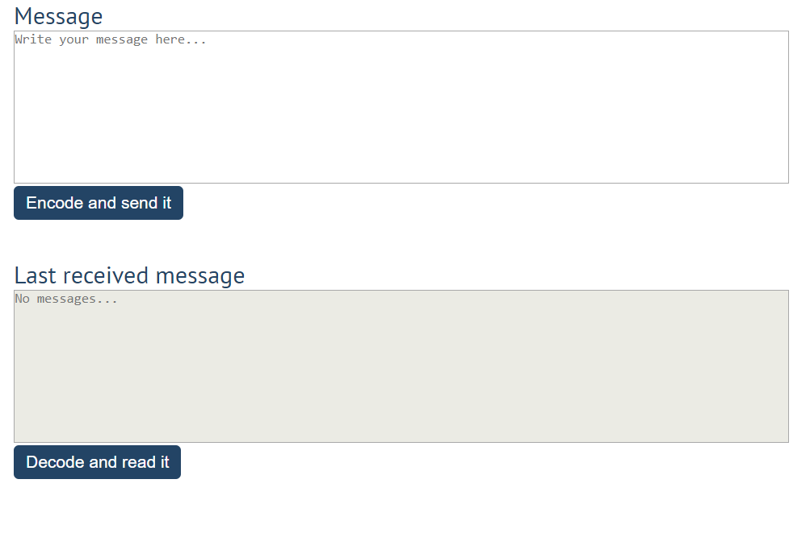

This program should contain **two functionalities**.

The first one is to **encode the given message** and **send it** to the **receiver**.

The second one is to **decode the received message** and **read it (display it)**.

When the [**Encode and send it**] **button** is clicked, you should get the given message from the first **textarea**. When you get the current message, you should encode it as follows:

* **Change** the **ASCII CODE** on **every single character** in that message when you **add 1** to the current **ASCII NUMBER**, that represents the current character in that message
* **Clear** the **sender** **textarea** and **add** the encoded message to the **receiver textarea**

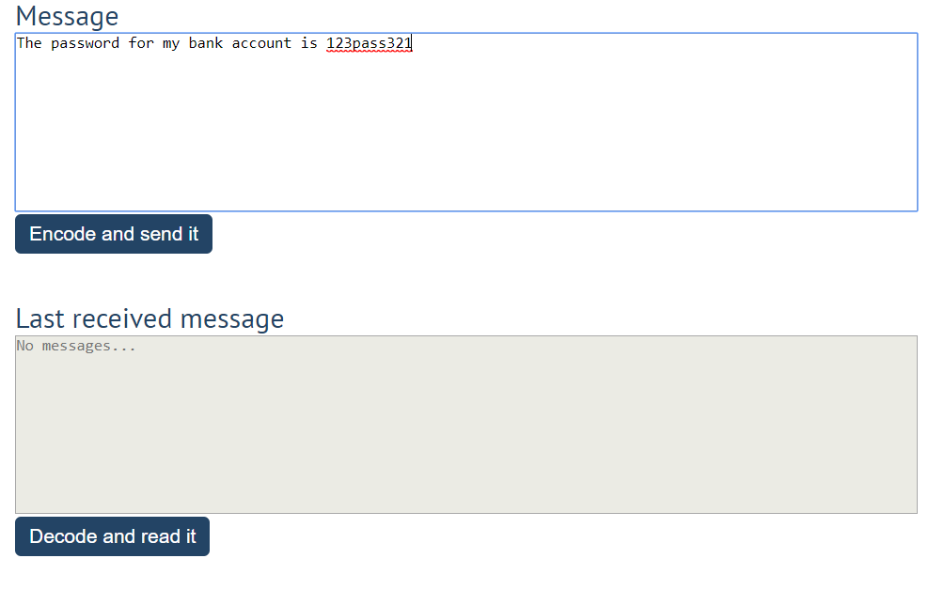

After clicking the [**Encode and send it**] **button** the result should be:

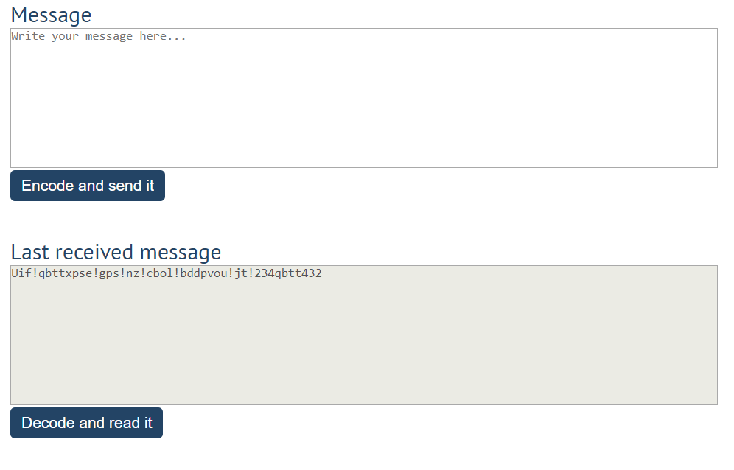

After that, when the [**Decode and read it**] **button** is clicked. You need to get the **encoded message** from **the receiver textarea** and do the **opposite logic** from encoding:

* **Subtract 1** from the current **ASCII NUMBER**, that represents the current character in that message
* Replace the **encoded message** with the already **decoded message** in the receiver **textarea**, to make it readable

